1. Issue faced: Git unable to push files to the remote repository as some other account was being accessed. The said account was created earlier and so Git was trying to link the remote repository to that account

**Solution:**

Goto Control Panel and select **Manage User Credentials** under **Credential Manager**

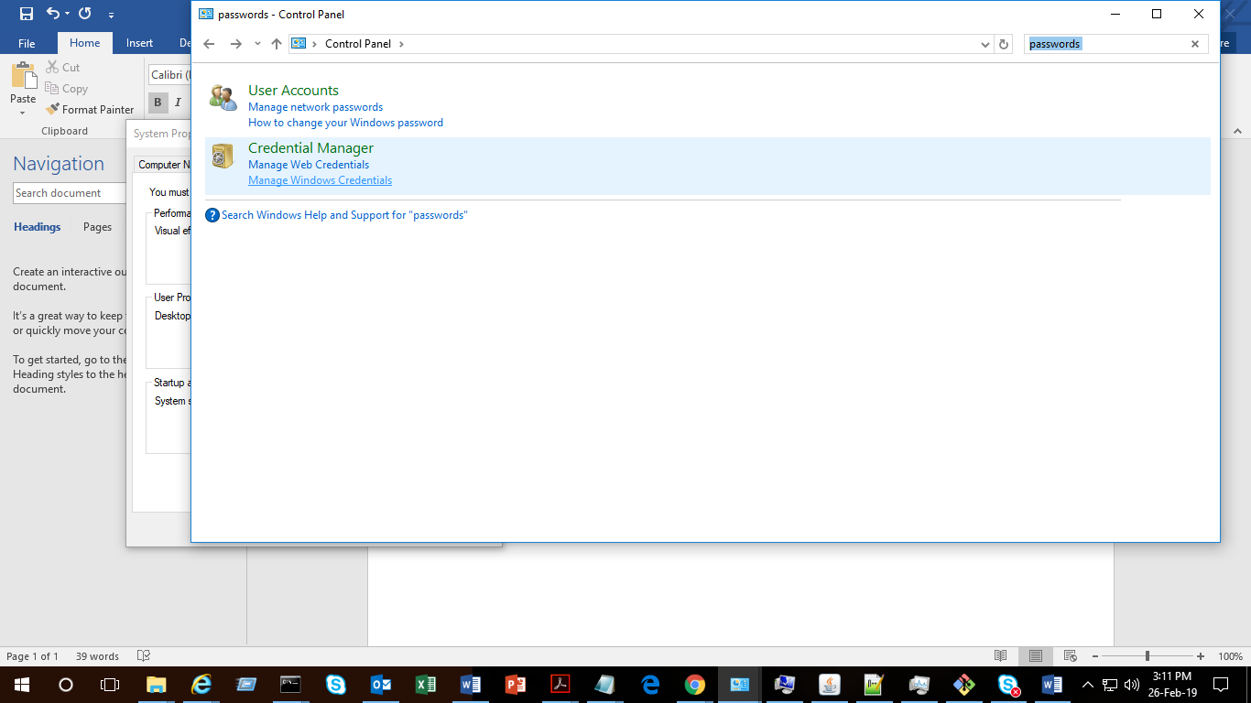

Here check the git credentials stored and remove those stored credentials. You can then login with the desired account.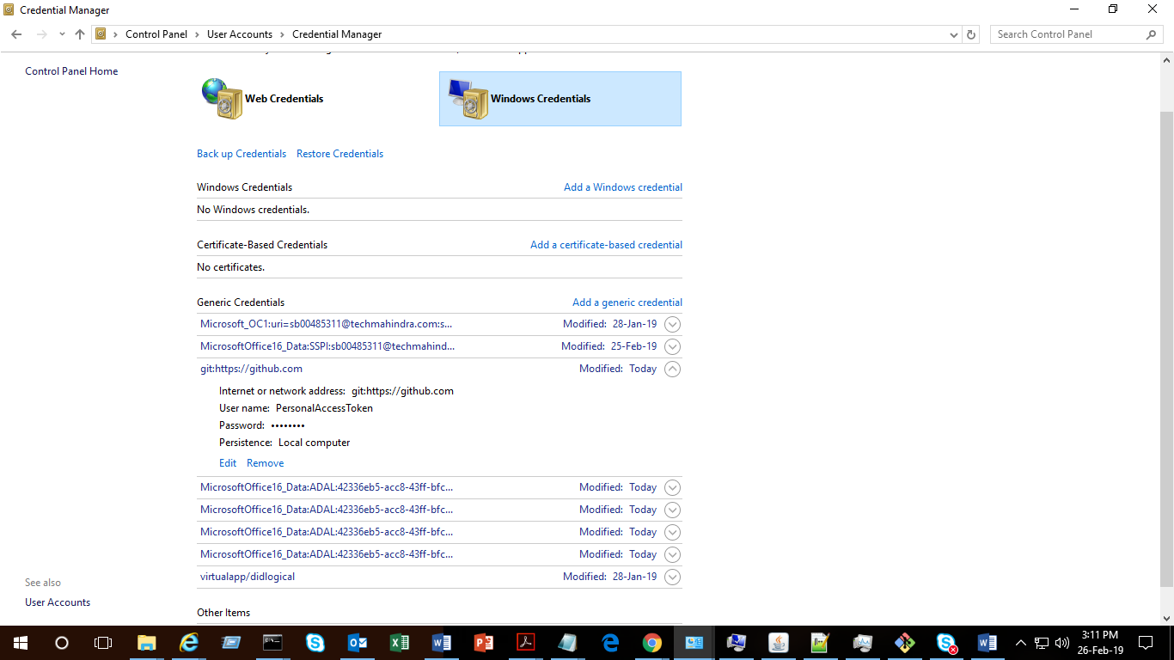

Note: This can be done for similar issues for other tools